Generative AI Pilot for Sierra AI

Background
Partnering with the Blues Association and Sierra.ai we are evaluating the technical capabilities to create and then reduce the need for humans to be the only interactivity we have with our members. To frame the scope of we are looking to test and validate we are looking to evaluate the following:

- AI Voice Agent for member and provider calls
- Starting with FEP Member Population
- Pilot Use Cases: Benefits & Coverage Inquiries, Eligibility Inquiries, Claims Status,
- Reduce Live Agent Calls, Lower Average Handle Time, and Improving Member Experience

Hypotheses
Customer Service Agentic AI solution will
- Reduce live agent call volume by 12.5% for pilot cases
- Reduce cost per call by reducing live agent use
- Reduce Average Handle Time with automated resolution
- Improve Customer Satisfaction (CSAT) and Net Promoter Score (NPS)

Quantitative Metrics
- Live agent call volume/ deflection
- Cost per call by reducing live agent use
- Average Handle Time with automated resolution

Qualitative Metrics
- Customer Satisfaction (CSAT) and Net Promoter Score (NPS)

Technology
- Functional Capabilities:
  - Sierra's AI models can seamlessly integrate with different CRMs and other business systems to both utilize data in customer facing interactions (outbound) as well as updating the CRM post-conversation (inbound)
  - Fine-tuned LLMs process and generate NLP responses.
  - Knowledge Graphs and Vector Embeddings help the AI Agents align with brand-specific terminology, policies, and guidelines.
  - Implements Rule-Based Constraints and Reinforcement Learning to ensure set goals are accomplished within pre-defined guardrails.
  - Utilizes emotion detection models and synthetic empathy algorithms to adapt responses based on user sentiment and engagement.
  - Uses contextual memory and retrieval-augmented generation (RAG) to maintain conversational history and provide personalized recommendations.
- Non-Functional Capabilities:
  - Advanced multi-model AI Architecture which includes supervisory models that oversee and ensure the quality of responses which reduces hallucinations.
  - End-to-End encryption and GDPR/CCPA compliance measures.
  - Omnichannel Support (Web, Mobile, Messaging and Voice Apps)

Pre-Pilot
- Determine Stakeholders, Use Cases, Dates, and Success Measures.
- Blue Shield of California
LOB | Sub LOB | Task | Business Description | Annual Volume | Current Containment Rate | Keep / Retire | Candidate for Conversational AI | Candidate for Visual IVR
Member | Large Group | Task 1 | Task 1 provides a readout of X or status for Y | 10,000 | 15% | Keep | Yes | No
 |  | Task 2
 |  | Task 3

- Sunflower
LOB | Sub LOB | Task | Business Description | Annual Volume | Current Containment Rate | Keep / Retire | Candidate for Conversational AI | Candidate for Visual IVR
Member | Large Group | Task 1 | Task 1 provides a readout of X or status for Y | 10,000 | 15% | Keep | Yes | No
 |  | Task 2
 |  | Task 3

- Marin
LOB | Sub LOB | Task | Business Description | Annual Volume | Current Containment Rate | Keep / Retire | Candidate for Conversational AI | Candidate for Visual IVR
Member | Large Group | Task 1 | Task 1 provides a readout of X or status for Y | 10,000 | 15% | Keep | Yes | No
 |  | Task 2
 |  | Task 3

- For Sunflower, leverage the chat functionality to support first call resolution. Their current cost per call is $38.57/call. So looking for any opportunity to lower that.
- Marin, i just understand they are interested and their current call center is overloaded...so much so that BSC is leaning in and providing Call Center support. So there is opportunity there.

Pilot dates
- Go/no go date:
- Pilot launch date: July 1st, 2025
- Interim results:
- Pilot complete:
- Final results:

Procurement Process

 | Sierra | ASAPP
SOW | PTP to provide by 4/22 | PTP to provide by 4/25
GBS Ticket | RITM4151442 | RITM4160242
Vendor Risk Security Assessment | RITM4188282 | RITM4189394
Tech Scorecard/TAF | Chendra to complete | Chendra to complete

Pilot Design
Phase 0

Objective: Test for Benefits inquiries in an isolated sandbox environment (simulated calls). Stellarus/BSC employees would call in with scripted questions to test how Sierra AI responds.
Desired Learnings
- How accurate are Sierra AI’s answers to questions answerable by the knowledge base it has access to?
- Does Sierra AI transfer “members” to a live agent at the appropriate time?
- How seamless are the call transfers? Is there any latency?

Sample benefit questions
- What is my out-of-pocket maximum?
- What is my deductible?
- What is my cost share for out of network providers?
Requirements
- Ability to houses “static” FEP plan benefit docs in a sandbox environment
- Ability to point Sierra AI to sandbox environment to retrieve information during a call

Evaluation Team
- Unmoderated track
  - Technical SMEs
    - PTP
      - Andy Leach, Andy Middleton
    - IT
      - Richie Gass, David Seeba
  - Ops SMEs
    - FEP Team
      - Joe Foley, Christia Grell, Nicole Brouillard
    - IVR Experience Team
      - Tony Diaz, Marc Harris, Kari Stanfill, Adina Ionescu
  - Everyone else
    - EAI
      - Jae, Prasanna, Vic, etc.
- Moderated track
  - As close to FEP members
    - Within Jae’s network (low-risk, but representative of FEP)

Internal Unmoderated Evaluations
Light-weight, but able to capture relevant perspectives

POC (Phase 0.A) Technical SME Evaluation Criteria [as outlined by PTP]
- Safety
  - Hallucinations safeguards
  - Baked-in Guardrails
- Human in the Loop
  - Does it know when to go to the human?
- Orchestration
  - Can it handle multiple questions in the same conversation?
  - Does it have a mechanism in place to engage with multiple data sources, live agents, human in the loop?
- Service Integration
- Deployment & Evaluation Tooling
- Use Case Fit

POC (Phase 0.A) Ops SME Evaluation Criteria
- Accuracy
- Operational fit
  - Does it follow a logical conversation? (context awareness)

POC (Phase 0.A) Internal everyone else Evaluation Criteria
- Response
  - Relevant answers
    - Provides accurate/relevant content per intent
  - Medical Advice
    - Does not provide medical advice

Moderated Evaluations
POC (Phase 0.B) Layperson/User Evaluation Criteria [Full Research Plan]
- Member Experience & Satisfaction
- How effectively might each solution support a positive member experience?
- Task Effectiveness
  - To what extent can each solution accurately identify member intent and successfully complete core tasks without live agent intervention (if/when live intervention is not warranted)?
- Escalation Logic & Risk Management
  - Do the solutions escalate calls appropriately when needed, and do they do so in a timely and contextually appropriate manner?
- Operational Efficiency & Flow
  - How efficiently does each solution manage interactions, minimizing overall duration, redundant steps, and conversational friction?
- Accuracy & Error Handling
  - How reliably does each solution avoid factual or contextual errors, and how effectively do they recover from errors when they occur?
- Human-Centered Communication & Context Awareness
  - How effectively does each solution engage in human-centered communication, demonstrating empathy, clarity, and appropriate use of context to support a professional and personalized member experience?
Vendor Sandboxes
- Sierra
  - 1-888-311-1620
  - Testing happy path
    - Are you calling as a healthcare provider? --> No
    - Please say your plan type --> Focus, Standard, Basic (any) (this will be the plan that it then answers questions using)
    - What can I help you with? --> Benefits
- ASAPP
  - 1-916-314-0701
  - Testers should:
    - Reply 'no' at the healthcare professional question
    - Provide one of the four test member IDs
      - FEPBlueBasic = 12345
      - FEPBlueStandard = 23456
      - FEPBlueFocus = 34567
      - No Plan = 45678
Benefit Script

- What is my deductible?
- What is my copay for a primary care visit?
- What is my out-of-pocket maximum?
  - How close am I to reaching my out-of-pocket maximum?
- What services are covered under my plan?
- How many physical therapy sessions do I have left?
  - What happens if I exceed my annual physical therapy sessions?
- Do I have out of network coverage and at what reimbursement rate?
- How are ER visits covered?
- How do I request coverage for experimental or emerging treatments?

Documents/Resources shared with vendors

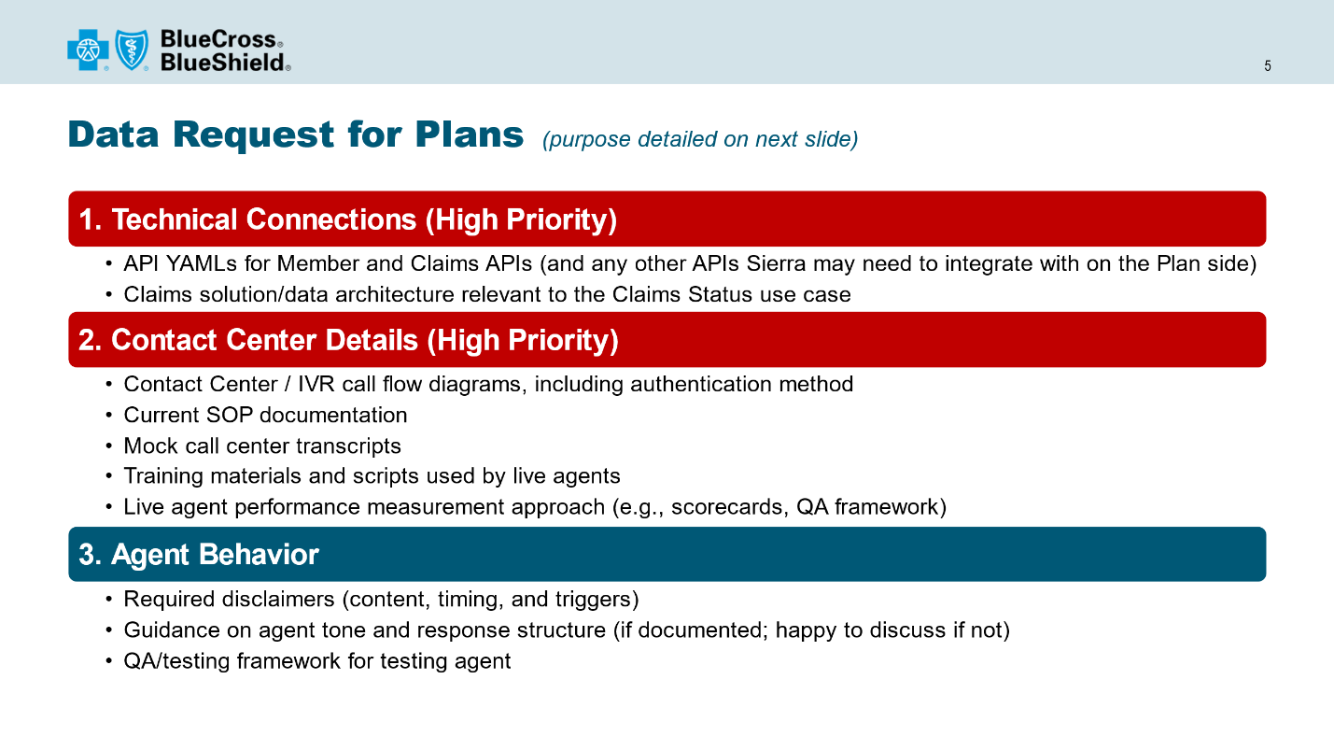

- Technical Connections – to be provided by Richie, David, Andy
  - API YAMLs for Member and Claims APIs (and any other APIs Sierra may need to integrate with on the Plan side)
  - Claims solution/data architecture relevant to the Claims Status use case
- Contact Center details – to be provided by Christia Gell/Nic Brouillard
  - Contact Center / IVR call flow diagrams, including authentication method
  - Current SOP documentation
  - Mock call center transcripts
  - Training materials and scripts used by live agents
  - Live agent performance measurement approach (e.g., scorecards, QA framework)
- Agent Behavior
  - Required disclaimers (content, timing, and triggers)
  - Guidance on agent tone and response structure (if documented; happy to discuss if not)
  - QA/testing framework for testing agent

Phase 0.b [TBD: API integration? Member specific data? Or still “static” general policy docs?]

Objective: Deploy Sierra AI and one other vendor (ASAPP?) to a real BSC call flow and compare to other solution to compare how each vendor handles non-scripted call interactions.
Desired Learnings
- How accurate are Sierra AI’s answers to questions answerable by the knowledge base it has access to?
- Does Sierra AI transfer “members” to a live agent at the appropriate time?
- How seamless are the call transfers? Is there any latency?

Sample benefit questions

Requirements

Phase 1 [TBD use cases, data, integration requirements]

Objective: Deploy Sierra AI and/or alternative GenAI vendor to real BSC call flow with integration into FEP Direct, Member 360 to evaluate ability to calls requiring member specific data.

Desired Learnings
- How accurate are Sierra AI’s answers to questions answerable by the knowledge base it has access to?
- Does Sierra AI transfer “members” to a live agent at the appropriate time?
- How seamless are the call transfers? Is there any latency?

Sample claims questions
- What is the status of xyz claim?
- Why was xyz claim denied?

Requirements
- Ability to integrate Sierra AI with FEP Direct, Member 360

Macro-level Evaluation Criteria (applicable through pilot)

- Functional/business eval - how well does the solution do what we need? does it deliver the anticipated product impact?
- User experience eval - how well do solutions meet needs of users? (internal project team, SMEs, regular users)
- Technical eval - how well do solutions handle our non-functional criteria

Post-Pilot

Users
- Federal Employee Program
- User Group
  - User Name, Title

Stakeholders
- Paul Markovich, President. Ascendiun; CEO, Stellarus
- Bill Giard, Chief Technology Officer, Stellarus
- Mike Peterson, VP Developer and Employee Experience, Stellarus
- Melissa Honour, VP of Product, Stellarus
- Zoher Karu, VP of Data Analytics, Stellarus

Pricing
- Pricing is not publically available but they have an outcome based pricing model.

Examples of user interface
- [include examples of UI, including photos]

Important File Locations
- File Name – Link

Artifacts
- Artifact - link

Next Steps
- Step 1 (Name)
- Step 2 (Name)

Assumptions
- FEP members will actually want to engage with a virtual agent when they call in.
- The calls the virtual agent can reliably handle represent a large enough proportion of FEP calls to realize true benefit

